Mate In One
Source: https://open.kattis.com/problems/mateinone

Problem
When you are looking back in old editions of the New in Chess magazine, you find loads of chess puzzles. Unfortunately, you realize that it was way too long since you played chess. Even trivial puzzles such as finding a mate in one now far exceed your ability.
But, perseverance is the key to success. You realize that you can instead use your new-found algorithmic skills to solve the problem by coding a program to find the winning move.
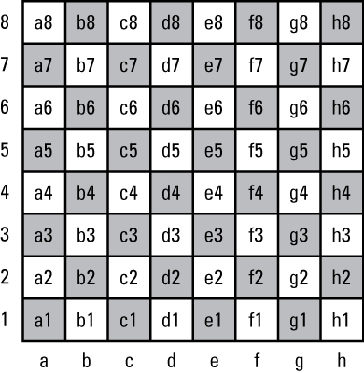
You will be given a chess board, which satisfy:
- No player may castle.
- No player can perform an en passant
- The board is a valid chess position.
- White can mate black in a single, unique move.
Write a program to output the move that white should play to mate black.

Input
The board is given as a grid of letters.
- The first line is rank 8 on the chess board, and the last row is rank 1.
- The first column is the a-file, and the last column the h-file.
Each character represents a piece as follows:
 | White | Black
Pawn | P | p
Knight | N | n
Bishop | B | b
Rook | R | r
Queen | Q | q
King | K | k
Empty Square | .

Output
Output a move in the form a1b2, where a1 is the square to move a piece from (written as the file, a-h, followed by the rank, 1-8) and b2 is the square to move the piece to. [x, y]

Sample Input 1 | Sample Output 1
rn...q.b  pb..pPkp  .p......  ..ppN..p  ...P....  ..NB....  PPPQ.PP.  ..KR.... | d2g5

Sample Input 2 | Sample Output 2
..kr...r  p..n..pp  .p.Bnp..  ....p...  ........  ........  PPP..PPP  ...RKB.R | f1a6

Sample Input 3 | Sample Output 3
rnbq..kr  .p.n..pp  p...p...  ...pP...  ......Q.  B.PB....  P.P..PPP  R....RK. | g4e6

Sample Input 4 | Sample Output 4
r.bqkb.r  pp.npppp  .....n..  .....N..  ...PN...  ........  PPPBQPPP  R...KB.R | e4d6

Sample Input 5 | Sample Output 5
........  .....p..  ...p....  b...Q.K.  k.nq....  p..NR..r  ..P..P..  R..Bn... | e5e8

Sample Input 6 | Sample Output 6
.rbq..r.  p.Pk.K.b  .P.bnp..  ..n....p  ........  ........  ....p...  ...R.... | c7b8

Solution
Generate all moves for white
Check each move for potential checkmate
Checkmate occurs if for every generated move for black there exists a generated move for white that kills the king.

